REIMAGINE RTS Overview
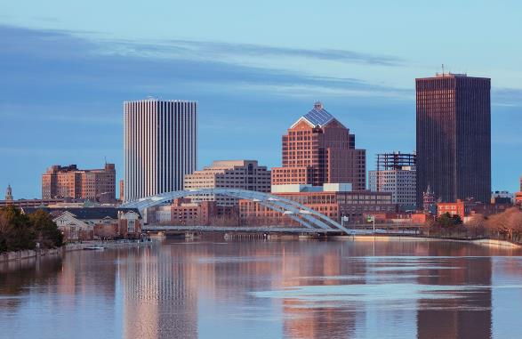
The public transit system in Monroe County has essentially been the same for decades; designed when downtown Rochester was the center of our community from every perspective. Since then, the demographics of our area have changed, the locations of employment centers have changed, and the number of available transportation options has changed. RTS has made some adjustments over time, but the structure of the transit system is the same. RTS constantly receives requests for more transit, for better transit, and for transit that is more frequent. These requests come from every corner of the county, specifically from business owners, senior citizens, millennials, individuals with disabilities, and those working to transition from poverty to prosperity. With more businesses locating to areas of our region that are not served well by public transit, if at all, we expect the demands for more to continue growing. This has created a new reality for public transit that we will not ignore.
IMAGE DESCRIPTION: Photo of the Rochester city skyline.
RTS hired TMD, a consulting firm with national transit experience, to conduct a study of the public transit system in Monroe County. TMD’s task was to identify for us what the fixed-route transit system should look like. In other words, where the 40- and 60-foot buses should go and with what frequency. Good fixed-route transit runs with regular and consistent frequency throughout the day, on weekdays and weekends. This is what TMD has recommended for the fixed-route transit system in Monroe County.
Public transit works best in a community where there is a convergence of density, diversity and design. For transit to be successful – as TMD states in their completed report – “there must be enough density to provide riders; diverse uses that generate all-day all-week demand; and streets that are designed for all modes and users. Without these key characteristics, providing efficient transit service becomes a challenge.”

Benefits of the fixed-route system recommended by tmd
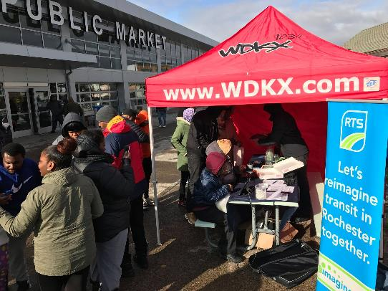
TMD’s recommendation offers RTS customers benefits that are not provided by the current system. The proposed fixed-route system offers the following:
IMAGE DESCRIPTION: Photo of customers interacting
with a Reimagine RTS/WDKX pop up booth at the Rochester Public Market.
- Ten routes with 15-minute bus service between 6am and 6pm during the week (example: Route 47 Monroe Short Line).
- Consistent coverage on weekdays and weekends – meaning the routes that run during the week will also run on the weekend.
- 95% of current customers will be within walking distance of the recommended system.
- 64% of current customers will have access to the 10 frequent routes.
In addition to offering a better design for the fixed-route system in our community, TMD’s recommendation aligns with the Rochester-Monroe Anti-Poverty Initiative recommendation of high-frequency cross-town transportation.

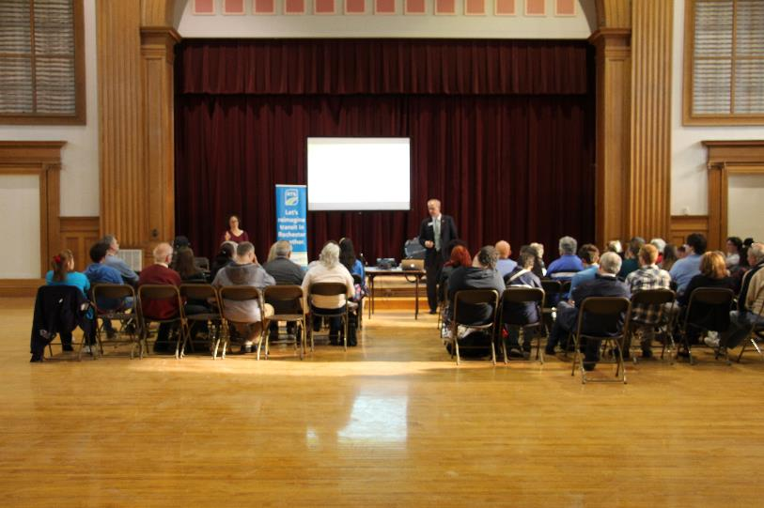
community input informed the Reimagine RTS Process
IMAGE DESCRIPTION: Photo of audience listening to CEO Bill Carpenter during Reimagine RTS information session.
Another reason the Reimagine RTS study has been successful to this point is the amount of community participation in the study process. Since the public launch of the study in September 2017, we conducted more than 150 outreach sessions with customers, employees and stakeholders. Spanish language and Sign Language interpreters were present at many of the events. We collected nearly 14,000 surveys online and in-person at the outreach sessions. We placed advertisements with newspapers, radio stations, outdoor poster boards, on the sides of buses, and on digital media. Below is a comprehensive summary of all of the advertisements and communication methods:
- Advertising Channels:
- Newspaper: Democrat and Chronicle
- Radio: WAIO-FM, WHAM-AM, WRMM-FM, WBEE-FM, WCMF-FM, WPXY-FM, WDKX-FM,
- Digital: Display, Facebook
- Outdoor: 7 Poster Boards
- Transit: Outside of 20 buses
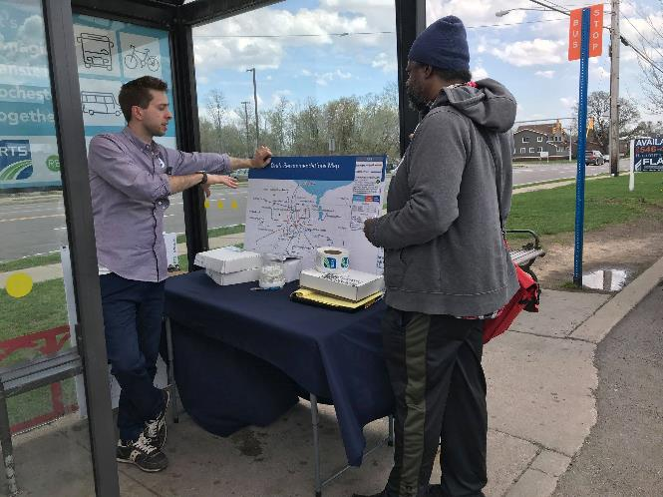
- Other Communication Channels:
IMAGE DESCRIPTION: Photo of a RTS representative speaking with a
customer about Reimagine RTS at a pop up session at the Irondequoit Plaza bus stop.
- Email Newsletter
- SMS News
- Digital Signage & Posters in Transit Center
- Brochures
- Business Cards
- Social Media (Facebook, Twitter, LinkedIn, Instagram)
- On-the-Bus Posters and Rail Cards
- Radio Spot played on buses
- Shelter Posters
- Website Information at myRTS.com/Reimagine
- Overview Video
- Community Outreach - Grass Roots Efforts
- News media coverage with local print, radio and television outlets
Information was provided in other languages, including braille, when requested.

